First Challenge: Show that the SECI Model is an instance of the KIM pattern.

The KIM Model [1]:
The Knowledge Insight Model or KIM for short is a framework to manage knowledge. There are four concrete representations of this model called Framer, Maker, Sharer and Finder. The primary idea behind the model to provide some way for the organization to know and take advantage of all the knowledge that already exists and can be external to the organization. The major problem with knowledge is that organization know that it exist but most often do not know how to consolidate it and in what form. Another eluding item is the form of knowledge. Many organizations like IT companies, government bodies etc. fail to realize the form of existing knowledge. This leads to suboptimal usage of resources as well as hinders in the creative as well as systematic growth of an organization.
KIM is a helpful framework to organize exiting knowledge as well as to put to use external knowledge. The KIM model aims at process improvement by refining the knowledge gathered from external and internal sources. This is a cyclic process where the knowledge gathered from internal and external sources are refined until it reaches an allowable threshold of executable process.
Processes of an organization depend on the factors effecting both the internal as well as external environment. A process can be viewed to be translating cyclically between two states: discover and refine. Where discover can be seen as the stage where input is gathered from internal as well as external sources like customer perception, board meetings etc. and this knowledge becomes input of the refine stage where a formalization of the knowledge into useful process takes place. The output of refine stage is again passed to discover stage to try it with new parameters. This alteration takes place till a satisfactory process is in place.
The above figure [1] is taken from the Knowledge Enabling Organon book. It shows the above model in a conceivable grid format.

SECI Model [3]:
The SECI model was given by Ikujiro Nonaka and his colleagues (Nonaka 1994; Nonaka et al. 1994; Nonaka & Takeuchi 1995; Nonaka et al. 2000; 2001a; Nonaka & Toyama 2003) [3]. This model shows how knowledge is created and passed as well as different forms of knowledge affecting an organization.
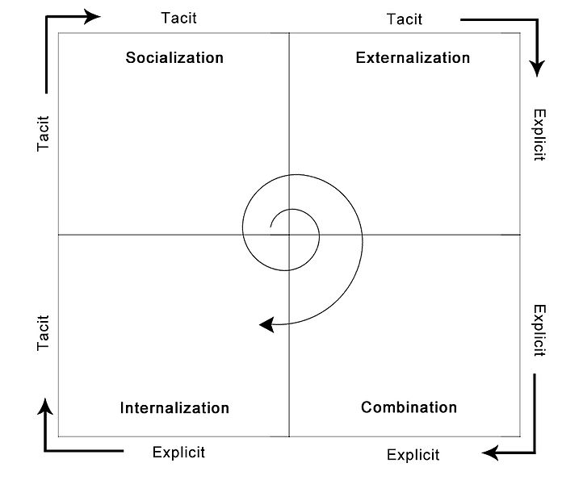
The above figure [4] shows the knowledge dimensions of SECI model. In the SECI model knowledge transfer is of the following forms
- Tacit to Tacit (Socialization): This form of knowledge sharing happens through mostly personal interaction, and face to face communication. This is a non-formal mode of knowledge sharing where nothing is documented.
- Tacit to Explicit (Externalization): In this form of knowledge transfer, knowledge is converted into communicable forms like table, figures, images etc.
- Explicit to Explicit (Combination): In this form of knowledge transfer and sharing different form of explicit knowledge of the organization is combined to build prototypes and thus form new forms of explicit knowledge.
- Explicit to Tacit (Internalization): This is learning by doing form of knowledge transfer. In this form explicit knowledge from inside and outside the organization is used by individuals or collaborations to create new creative and valuable knowledge within the organization.
Comparison of KIM and SECI models
In this work we are to compare SECI and KIM models and establish that SECI is an instance of KIM model. In the above two sections I have discussed the basic framework of both the models. In this section I will establish that SECI is a type of KIM model. To do so I will compare each of the knowledge transformation phase of the SECI model a specific phase of the KIM model. Now in order to establish this relation I will try to take the path that is mentioned in the KEO book. According the book the Kim model and all the actors (internal/external discoverers and internal/external refiners) can be neatly grouped into four categories of PDCA cycles; namely – framer, maker, sharer and finder. This can be succinctly summarized in the figure below (taken from the book)
The above figure shows the various flow of knowledge to and from the discovery and refinement (with both external and internal actors). These flows can be further broken into the framer, maker, sharer and finder modes. For example the framer pattern which is a pattern for finding out the knowledge that is needed and how to get it can be shown from the below figure (taken from the KEO book)
As can be seen from the above figure is a part of the bigger KIM model.
Now for the comparison part I will map the four phases of the SECI model to the KIM model
- Tacit to Tacit: this part of knowledge transfer can be realized from the following image part
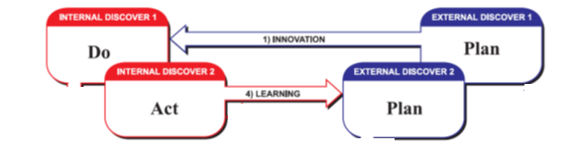
The above image is a part of the KIM model. As can be seen from the above picture there is no formal refinement of the knowledge, i.e. knowledge is not documented. It is shared and innovated only from personal experience or socialization.
- Tacit to explicit: the below image shows this form of knowledge flow
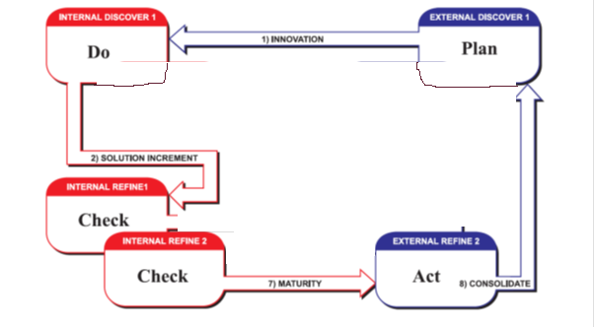
As can be seen from the above figure now the refine actors (internal and external) come into picture. This is the state where tacit knowledge is formalized and is used to create new knowledge.
- Explicit to Explicit:
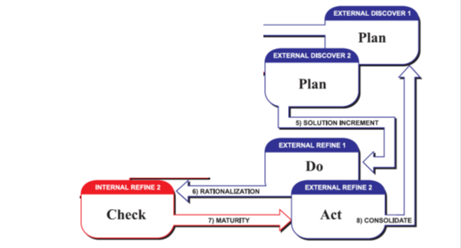
The above figure shows the explicit to explicit conversion. Where various documented knowledge are combined and refined to make prototypes.
- Explicit to tacit:
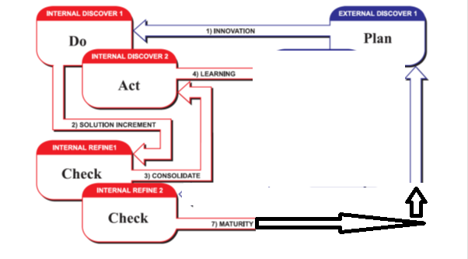
In the explicit to tactic model the knowledge gathered from outside the organization and what has been formally assimilated internally is combined is used creatively to derive new knowledge by learning by doing.

References
[1] Knowledge Enabling Organon book
[2] http://en.wikipedia.org/wiki/SECI_model_of_knowledge_dimensions
[3] http://en.wikipedia.org/wiki/File:SECI_Model.jpg

